**ELEC-E7120 Wireless Systems**

**Homework for Unit 4**

Name: Xingji Chen

Student Number: 101659554

**Problem 4.1 (1.5 points).** *Effect of the Frequency Reuse Factor in a Cellular network*

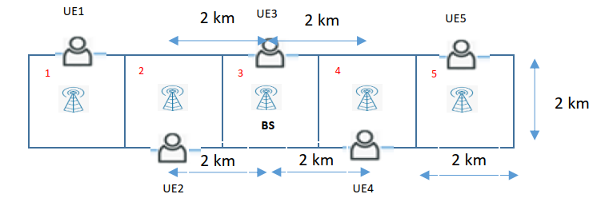

Figure 1. Simplified cellular network that provides coverage along a long-horizontal stripe (e.g., next to a highway). Cells are assumed to be squares of size 2 km x 2 km, with one base station in the center. For simplicity, only one mobile user (UE) is assumed per cell, whose location is precisely north (up) in cells with odd indexes and south (down) in cells with even indexes. If in your opinion there is any missing information, please propose a given value for the missing parameter using your common sense.

Consider a one-dimensional cellular system deployed, for example, along a highway as shown in Figure 1. The system has square cells whose sides have a length of 2 km. This problem focuses on the downlink direction of communication, from base stations to mobile terminals. Assume that each cell has one mobile user located as shown in the figure. Assume that the total transmit power at each base station is 𝑃𝑡 = 40W. The communication takes place on a frequency band with bandwidth 10 MHz, and the noise power spectral density (𝑁0) in reception is -174 dBm/Hz. Without loss of generality, we consider that the mean path loss follows the model 𝐿(𝑑) = 137.4 + 35.2 𝑙𝑜𝑔10(𝑑), where 𝑑 is the distance between the transmitter and receiver in kilometers (km). For simplicity, we neglect the effect of multipath fading and shadowing when modeling the wireless channel. Determine:

1. The Signal-to-Noise-plus-Interference power Ratio (**SINR**) and Signal-to-Interference power Ratio (**SIR**) of the mobile user in the central cell (i.e., UE3), when the frequency reuse factor in the cellular deployment is 1 (i.e., all cells use the whole bandwidth to serve its associated users) and frequency reuse factor 1/2 (i.e., bandwidth is divided into two portions, such that same resources are reused in every second cell in order to increase the reuse distance).
2. The achievable date rate that the user in the central cell (i.e., UE3) can receive in the downlink in both cases (i.e., when frequency reuse factor 1 and 1/2). When computing this value, assume that all co-channel interference coming from the other cells should be treated as AWGN (i.e., R = Wlog2(1+ SINR)).
3. Which of the previous frequency reuse factors was the one that provides the best performance from a network level perspective? Draw your own conclusions according to the results obtained.
4. SINR and SIR
5. Frequency reuse factor is 1

In this case, all cells use the entire bandwidth, so there is the biggest interference from other cells.

* SINR

The total transmit power at each base station is



The received signal power *Ps* is



The interference signal from cell 2 and cell 4 are the same, which is



The interference signal from cell 1 and cell 5 are the same, which is



The noise power is



Hence, the SINR is



* SIR

The SIR is



1. Frequency reuse factor is 1/2

In this case, each cell uses the half of the bandwidth and neighboring cells use different frequency

* SINR

The total transmit power at each base station is



The received signal power *Ps* is



The interference signal from cell 1 and cell 5 are the same, which is



The noise power is



Hence, the SINR is



* SIR

The SIR is



1. Achievable data rate
2. Frequency reuse factor is 1



1. Frequency reuse factor is 1/2



1. At two different frequency reuse factors, the system can achieve essentially the same rate. The rate of the first case is slightly larger than that of the second case, this is because the system has larger bandwidth in the first case.

With a frequency reuse factor of 1, the cochannel interference is larger, the SINR is lower, but the bandwidth is larger. When the frequency reuse factor is 1/2, although the bandwidth is reduced, the cochannel interference is weakened and the SINR is increased.

Therefore, if the aim is to increase the data rate, the first case is better. If the aim is to reduces the same-frequency interference and improves the stability of the network, the second case is better.

**Problem 4.2 (1.5 point).** *Sectorization principle and directive antennas*

Consider the communication system as shown in Figure 2, composed of two base stations (BSs) and a mobile station (MS). Assume two cases, which are differentiated as follows:

* Case-A: Both BSs do not apply sectorisation, deploying omnidirectional antennas with 2.1 dBi gain in the horizontal plane.
* Case-B: Both BSs do apply sectorization using directional antennas. Here, the main direction of the irradiated power in each BS is denoted by a solid arrow (black) below.

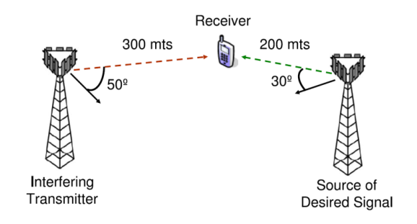

Figure 2. Simplified mobile communication system composed of two base stations and one mobile station. Base stations apply sectorization, using directional antennas with a pre-defined gain pattern.

The aim is to determine the maximum SINR (in dB) that would be feasible at the MS in both cases when the average path loss attenuation (in dB scale) is given by



where 𝑑 is the distance between transmitter and receiver in kilometers.

For sake of simplicity, we assume that both BSs apply the same transmit power. For the sectorization case (Case-B), we consider that the antenna gain pattern at both BSs attains the following form:



where 𝜃 is the angle of arrival/departure [degrees], 𝐺𝑚𝑎𝑥 = 16 𝑑𝐵𝑖 is the maximum antenna gain, 𝜃0 is the main direction of the irradiated power [degrees], 𝜃3𝑑𝐵 = 60° is the bean width at 3 𝑑𝐵, and 𝐺𝑓𝑏 = 25 𝑑𝐵 is the front-to-back ratio for the antenna Estimate the feasible spectral efficiency (i.e., date rate per unitary bandwidth) that the mobile user can achieve in both cases. When computing this value, assume that the thermal noise power is negligible with respect to the co-channel interference power, and that co-channel interference coming from adjacent cells is treated as AWGN (i.e., R = Wlog2(1+ SINR)).

1. Case-A: omnidirectional antennas

Assuming that the transmission power of both BSs is *Pt* and the gain of omnidirectional antennas is *Go* = 2.1 dBi.

The desired signal of receiver is



The interference signal of receiver is



Hence, the SINR is



The feasible spectral efficiency is



1. Case-B: directional antennas

The gain of directional antennas is



Hence,





The desired signal of receiver is



The interference signal of receiver is



Hence, the SINR is



The feasible spectral efficiency is



**Problem 4.3 (1 point).** *Spatial Multiplexing gain when using MIMO technology*

Let us assume that the target peak data rate in a 5G wireless network is 40 Gbps. Assuming a 16 x 8 multilayer MIMO system (i.e., *Nt* = 16 transmit antennas and *Nr* = 8 receive antennas), and a communication bandwidth of 500 MHz. Determine the following points:

1. What is the minimum SINR (in dB) that is required per data-stream (layer) to achieve this peak data rate?
2. How does the situation change when the number of transmit antennas increase to *Nt* = 32?
3. How many extra antennas do we need to deploy in the receiver if, for any given reason, the SINR that you computed in item a) drops by 10 dB?
4. The peak data rate of MIMO system is



So, the SINR is



1. When the number of transmit antennas increase to *Nt* = 32, since there is no increase in the number of *Nr*, so the number of data streams is no increase in the MIMO system, hence, the results are the same as question a.
2. The SINR is



The data rate of per data stream is



In order to reach the target peak data rate, the number of *Nr* should be



So, we need to deploy 12 receive antennas, the number of extra antennas is 4.